REAL-WORLD DATA PROJECT (RETAIL SALES ANALYSIS)

Project Title: Real-World Retail Sales Data Analysis

Submitted By: Ankita Kumari

Internship Program: Data Science Internship

Organization: Thiranex

Submission Date: June 2026

1. Introduction

In today's business environment, data plays a crucial role in decision-making and strategic planning. Retail businesses generate large volumes of sales data every day, which can be analyzed to understand customer behavior, product performance, and overall business profitability.

Retail data analysis helps organizations identify trends, evaluate sales performance, optimize inventory management, and improve customer satisfaction. Through data visualization and statistical analysis, businesses can make informed decisions that contribute to growth and profitability.

This project focuses on analyzing a retail sales dataset to uncover meaningful insights related to sales, profit, product categories, and customer purchasing patterns. Various data analysis techniques and visualizations were used to evaluate business performance and generate actionable insights.

2. Objective of the Project

The primary objectives of this project are:

- To analyze retail sales data and understand business performance.
- To identify top-performing product categories.
- To evaluate profit generation across different categories.
- To discover sales trends and patterns.
- To perform statistical analysis on sales-related data.
- To generate business insights through data visualization.
- To improve practical knowledge of real-world data analysis.

3. Dataset Description

The dataset used in this project is a Retail Sales Dataset containing information about customer orders, products, sales, profits, and regions.
The major columns included in the dataset are:

Order ID
A unique identifier for each order.
Category
Represents the main product category such as Furniture, Office Supplies, or Technology.
Sub-Category
Represents the specific product type within a category.
Sales
The revenue generated from product sales.
Profit
The profit earned from each transaction.
Quantity
The number of units sold.
Region
The geographical region where the order was placed.
Order Date
The date on which the order was placed.

This dataset provides valuable information for analyzing business performance and customer purchasing behavior.

4. Data Inspection and Statistical Analysis

Before performing visualizations, the dataset was examined to understand its structure and quality.

Dataset Information

The dataset information was obtained using the "info()" function.

The analysis included:

- Number of records
- Number of columns
- Data types
- Missing values

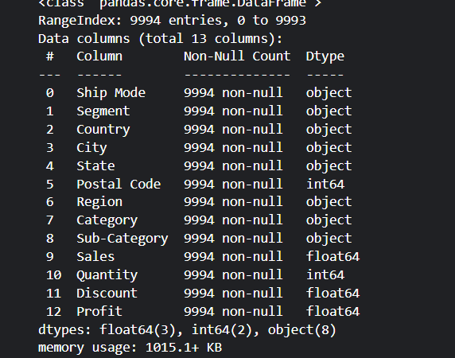

Statistical Summary

The statistical summary was generated using the "describe()" function.

The summary included:

- Mean
- Median
- Standard Deviation
- Minimum Value
- Maximum Value
- Quartiles

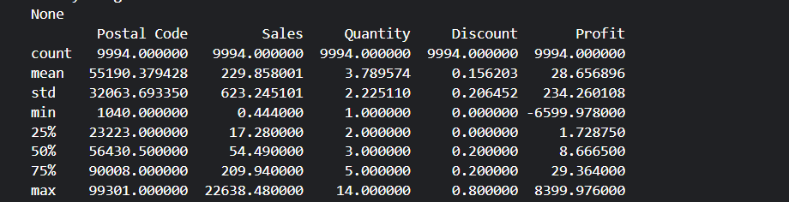

The statistical analysis provided a better understanding of sales distribution, profit variation, and product quantities.

5. Data Visualization and Analysis

Several visualizations were created to understand the dataset more effectively.

5.1 Sales by Category

A bar chart was generated to compare sales across different product categories.

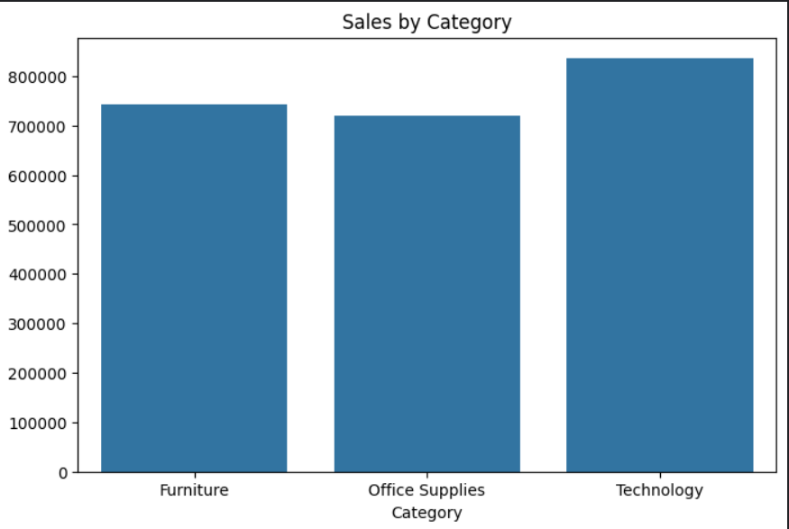

Observation

The visualization showed which product category generated the highest revenue. Categories with higher sales contribute significantly to overall business performance.

5.2 Profit by Category

A profit analysis was performed to identify the most profitable categories.

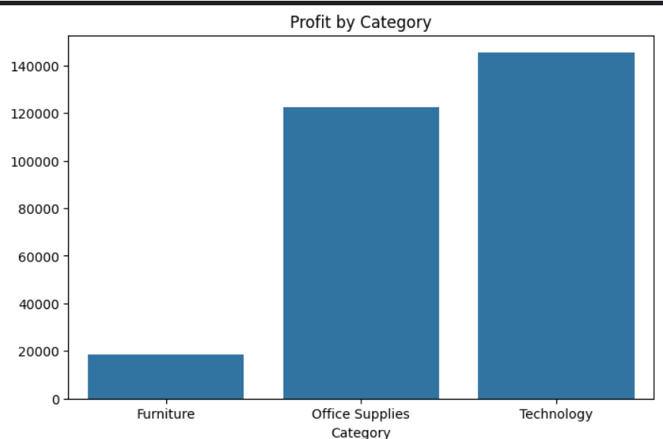

Observation

Some categories generated higher profits despite having lower sales, highlighting the importance of profit-based evaluation rather than focusing solely on revenue.

5.3 Top Products by Sales

The top-performing products were identified based on total sales.

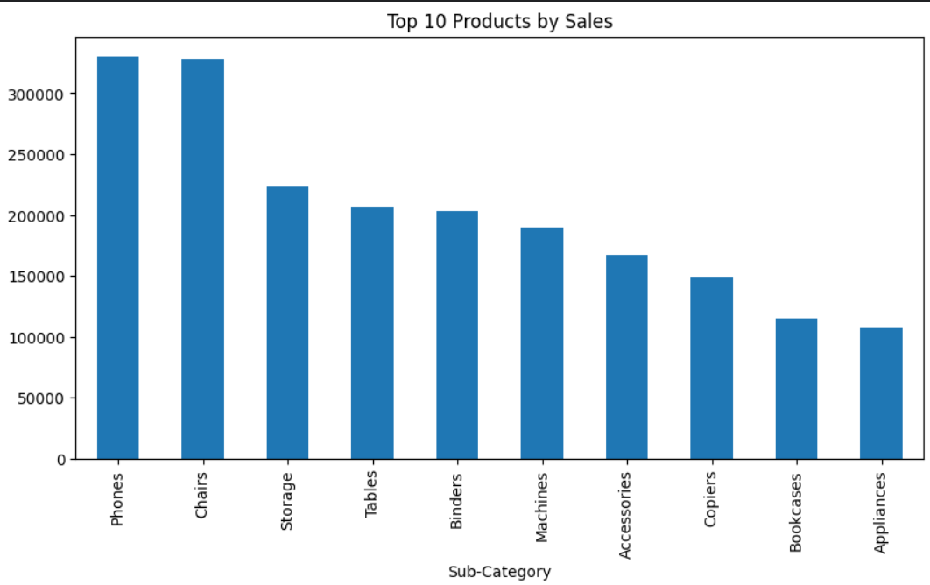

Observation

A small number of products contributed a significant portion of total sales revenue.

5.4 Sales Distribution

A histogram was created to examine the distribution of sales values.

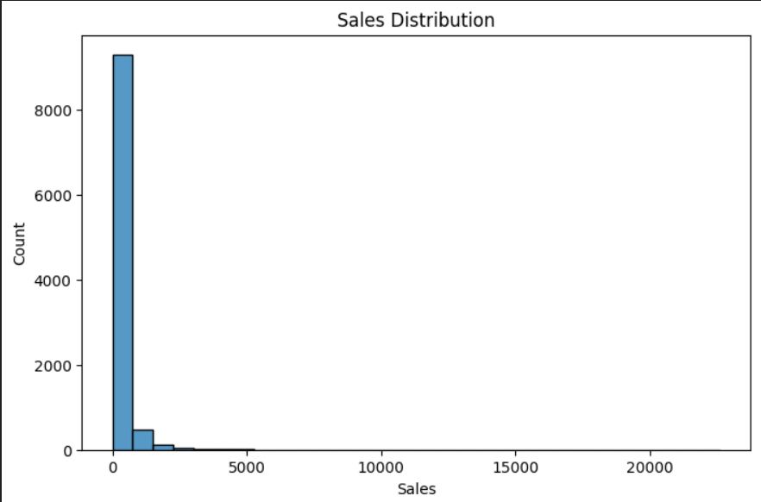

Observation

The sales distribution indicated that most transactions involved smaller sales amounts, while a few transactions generated exceptionally high sales.

5.5 Correlation Analysis

A correlation heatmap was generated to identify relationships among numerical variables.

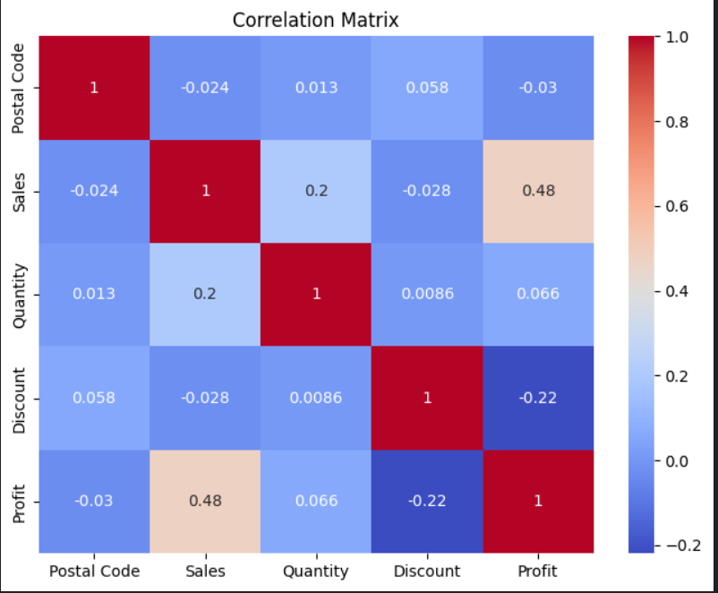

Observation

The heatmap highlighted positive and negative relationships between sales, profit, and quantity variables.

Understanding these relationships helps businesses make data-driven decisions.

6. Key Findings and Insights

The following insights were obtained from the analysis:

Insight 1

Certain product categories generated significantly higher sales compared to others.

Insight 2

Profitability varied across categories, indicating that high sales do not always result in high profits.

Insight 3

A limited number of products contributed a major share of total revenue.

Insight 4

Sales data showed uneven distribution, with some transactions generating exceptionally high sales values.

Insight 5

Correlation analysis revealed important relationships among business metrics such as sales, quantity, and profit.

Insight 6

Data visualization simplified the process of understanding business performance and identifying improvement opportunities.

7. Tools and Technologies Used

The following tools and technologies were used during the project:

- Python
- Pandas
- NumPy
- Matplotlib
- Seaborn
- Kaggle Notebook
- Google Drive

These tools helped perform data cleaning, analysis, visualization, and report generation efficiently.

8. Business Recommendations

Based on the analysis, the following recommendations can be made:

- Focus on high-performing product categories.
- Improve strategies for low-profit categories.
- Increase inventory availability for top-selling products.
- Use sales trends for better forecasting and planning.
- Monitor profitability alongside revenue generation.

These recommendations can help businesses improve operational efficiency and profitability.

9. Conclusion

This Real-World Retail Data Analysis Project successfully examined sales and profit data to uncover valuable business insights. Statistical analysis and visualizations helped identify sales trends, product performance, and profitability patterns.

The project demonstrated how data analytics can support business decision-making and improve organizational performance. Through this analysis, practical experience was gained in handling real-world datasets, creating visualizations, and generating actionable insights.

Overall, the project enhanced analytical thinking and strengthened understanding of real-world data science applications in the retail industry.

